**Introduction to Programming EE2310 Homework 7-1**

**103061142 楊淳佑**

**Problem**

* Complete shuffle functions for two versions of example codes: cards_nostruct.cpp and cards_struct.cpp.
* Complete a function to deal game cards for the struct versions (cards_struct.cpp).

**Solution, Program Flow & Structure**

**Shuffle Functions**

* Generate two random numbers as the switching target.

Here we set A and B

* Assign card A to a buffer. * >500 times.
* Assign card B to card A. Switch card A and B.
* Assign buffer to card B.

**Game Cards Dealing Function**

* Use Deal to save the first card to the p1 array. * 2 times
* Use Deal to save the first card to the p2 array. * 2 times * 2 times.
* Use Deal to save the first card to the table array. * 2 times

**Output Result**

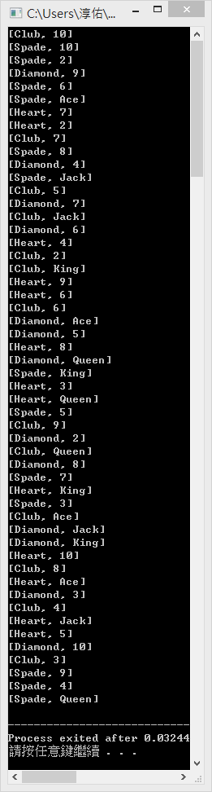 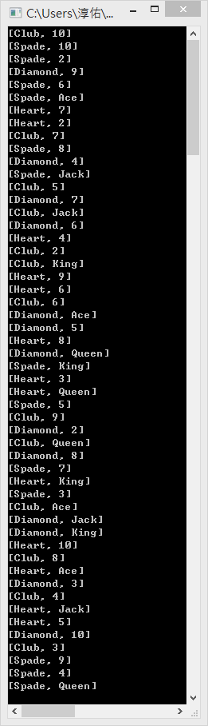 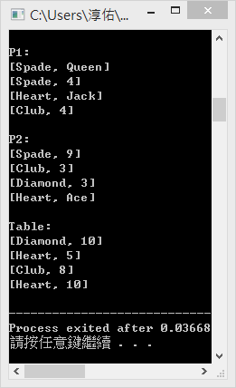

cards_nostruct.cpp cards_struct.cpp